A000-AFR-Gabon-Mahongwe Group-Kota People-Reliquary Figure-Osseyba-Brass-Wood-19th c

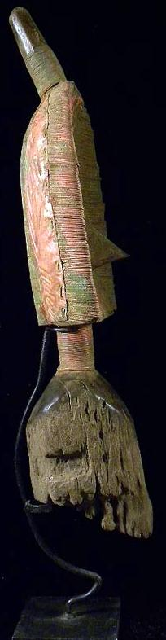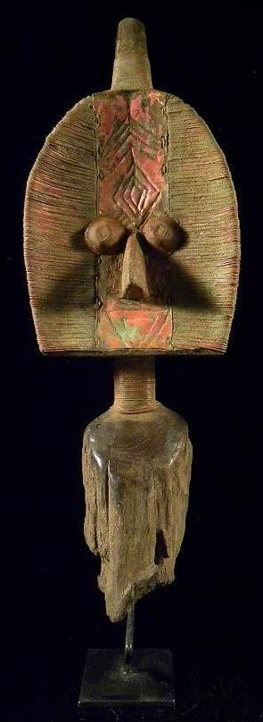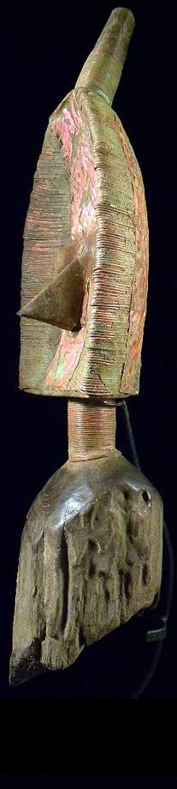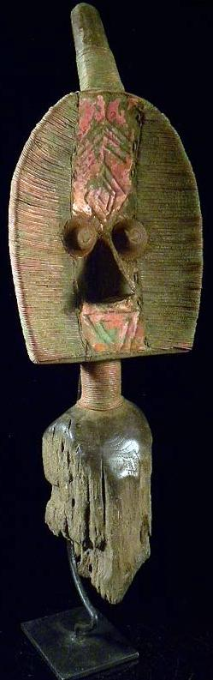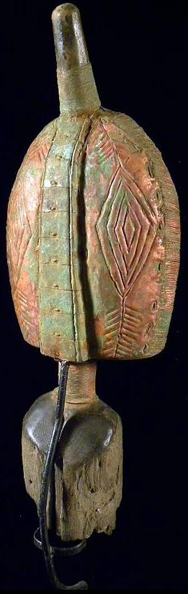

Figs. 1-5. Gabon-Mahongwe Group-Kota People-Reliquary Figure-*Osseyba*-Brass-Wood-19th c

**Case No.: 6**

**Accession Number:**

**Formal Label:** Gabon-Mahongwe Group-Kota People-Reliquary Figure-*Osseyba*-Brass-Wood-19th c

**Display Description:**

This *Osseyba* was the central part of an ancestral devotional cult of the Mahongwe Group and was conserved by Kota clan members (Perrois 1969: 9). Highly abstract Mahongwe *Osseyb*a are distinctive for their construction, which encases a wood core within a brass sheath, which are often described as "foliate" for their flattened leaf-like configuration. The three-dimensional design is subtly modulated by concavity of the face constructed on the carved-wood understructure and by the shifting surface textures of the applied metal wires and sheets. The shape of the head is ovoid, with a straight lower edge.

This superb *Osseyba* is considered the finest of its kind for its physical breadth and the artistry of its construction. The width of the head wide and the filaments that extend horizontally across the surface are tubular, affording the work greater surface contrast. The tips of those filaments are integrated into the decorative scheme of both the front and back sides. The virtuosity of the metalwork is apparent on the back, where folded filament tips form a delicate seam.

This *Osseyba* is surmounted by a cylindrical extension encased in brass wire at ca 30 degrees that represents a thick braid, called the *i-benda*, which is worn by notables as a traditional hairstyle known as *bakani* and was intended to deflect any adversaries from interfering with its power (Perrois and Siroto 1969b: 67).

On the reverse, this *Osseyba* displays complex adornment below the extension of the *i-benda*. Filaments have been wrapped around the edges so that their ends define an elegant alternating serrated border around the outer perimeter. A median axis composed of a raised ridge of ten segments with central nodules spans the entire length of the cranium. On either side of the band are lines that continue the segments of the raised ridge. This structure is suggestive of an abstract rendering of a **spinal column** **and with its central nodules may represent perceived neurological innervations, even perhaps, stages of hallucinogenic sensations as they appear to ascend the spinal column. As such this structure may have been used as a medical model and would imply that the Kota People are one of the very first to understand the rudiments of medical neurology.**

In Mahongwe society *Osseyba* were assigned guardianship of relics derived from singularly important individuals. According to Louis Perrois, the candidates worthy of contributing *Osseyba* included not only a clan's most distinguished male leaders but also mothers of an exceptional number of children or of twins, the latter being associated with prosperity and good fortune. Leon Siroto notes that those who distinguished themselves were perceived to be invested with shamanic powers that inhered in their skulls following their death. Close relatives in turn retained these *Osseyba* as a means of positively influencing the affairs of their extended family (Siroto 1969).

A broad median band extends from the upper rim to the horizontal base of the face. Two chevrons and four concentric diamonds decorate the head front and back. Two applied circular metal eyes have a staring aspect associated with spiritual or hallucinatory experience and are separated by the bridge of the beak-like nose, made from a projecting brass element. (Siroto 1969b: 87, fig. 8). Below the nose is one inverted triangle as a mouth element. On either side of the central axis, the surface is covered with carefully applied cut-metal bands that create a succession of horizontal striations. The cylindrical neck which is wrapped in brass wire mirrors the form of the coiffure. Below the neck the wood has deteriorated from having been placed within an ancestral relic basket.

*Osseyba* were taken out of seclusion by clan leaders and deployed in village rites in response to significant crises such as the death of a communal leader, the approach of an epidemic, or the launch of a dangerous hunting expedition. In order to address these concerns effectively and to fortify the community on these occasions, all the *Osseyba* of a village were collected in the main shrine in the belief that their combined power constituted a formidable protective barrier and an impenetrable shield.

**LC Classification:**

**Date or Time Horizon:**

**Geographical Area:**

**Map:**

**GPS coordinates:**

**Cultural Affiliation:**

**Media:**

**Dimensions:**

**Weight:**

**Condition:**

**Provenance:** Vienna, Austria

**Discussion:**

The sculpture displays a complex hair style on the reverse, where the filaments have been wrapped around the edges so that their ends define an alternating serrated border around the outer perimeter. At the center, aligned with and below the extension of the chignon, is a median axis composed of two parallel raised ridges that span the entire length of the back. On either side are bilat­erally symmetrical repoussé designs of a series of concen­tric triangles that reach to the outer edges. These densely stippled graphic patterns afford the work another textural dimension. Directly below the striated coiled neck, the plated surfaces of the base are embossed with a network of lozenges.

In Mahongwe society such works were assigned guardianship of relics derived from singularly important individuals. According to Louis Perrois, the candidates worthy of contributing relics included not only a clan's most distinguished male leaders but also mothers of an exceptional number of children or of twins, the latter being associated with prosperity and good fortune (Perrois 1969a: 11). Leon Siroto notes that those who distinguished themselves were perceived to be invested with mystical powers that inhered in their skulls following their death. Close relatives in turn retained these as a means of positively influencing the affairs of their extended family (Siroto 1969b: 22-23). The foliate figure that surmounts the relic was intended to deflect any adversaries from interfering with its power (Siroto 1969b: 86).

Such works were also taken out of seclusion by clan leaders and deployed in village rites in response to significant crises such as the death of a communal leader, the approach of an epidemic, or the launch of a dangerous hunting expedition. In order to intensify their potential to address these concerns effectively and fortify the commu­nity on such occasions, all the reliquaries of a village were brought together in the belief that their combined power constituted a formidable protective barrier and an impene­trable shield (Siroto 1969b: 27).

This type of a sculptural element from a Kota reliquary ensemble was the first example to be recognized in Europe as a major tradition of reliquary sculpture developed in eastern Gabon. A similar specimen dating to 1876 was collected by Oskar Lenz a geologist of the Deutsche Gesellschaft zur Erforschung Aqua­torialafrikas. His specimen (which he referred to it as a "fetish-idol" of the "Aduma" and "Oschebo" peoples of the Middle Ogooue River) has been in the Museum für Volkerkunde in Berlin since 1875 (Siroto 1969b: 24).We now know that specimens were created by peoples located between the eastern tributaries of the Lower Ivindo River: the Shake, BoNgom, and Ndambomo groups (Kele-speaking peoples) and the Mahongwe, BuSamai, and Kota groups (Kota-speaking peoples) (Siroto 1969b: 89).

**References:**

Perrois, Louis. 1969a. *Le Bwété des Kota Mahongwe du Gabon: note sur figures fueneraires des populations du bassin d'Ivindo*. Libreville: OSTROM.

Perrois, Louis. 1969b. Notes on the Bwuiti figures: response to Leon Siroto's article, 'The face of the Bwiti.'

Siroto, Leon. 1969a. Author's reply, *African Arts* 2 (no. 4),: 65-69.:

Siroto, Leon. 1969b. Masks and social organization among the Bakwele people of western equatorial Africa. Ph.D. diss. New York: Columbia University.

APPENDIX- **Comparable Artifact**

# AFRICAN OSSEYBA OR RELIQUARY FIGURE BRASS KOTA / MAHONGWE GABON CENTRAL AFRICA

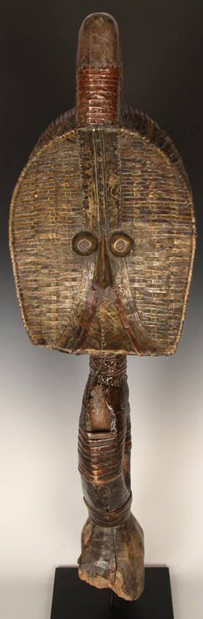 [gjpaw](http://www.ebay.com/usr/gjpaw?_trksid=p2047675.l2559) ([540](http://feedback.ebay.com/ws/eBayISAPI.dll?ViewFeedback&userid=gjpaw&iid=331749780705&ssPageName=VIP:feedback&ftab=FeedbackAsSeller&rt=nc&_trksid=p2047675.l2560) )

100% Positive feedback

|  |  |  |  |  |  |  |
| --- | --- | --- | --- | --- | --- | --- |
|  | [AFRICAN OSSEYBA OR RELIQUARY FIGURE BRASS KOTA / MAHONGWE GABON CENTRAL AFRICA](http://cgi.ebay.com/ws/eBayISAPI.dll?ViewItem&item=331749780705)   |  | | --- | | US $8,950.00 | | Shipping | $23.05  USPS Parcel Select Ground to United States | | Item number | 331749780705 | |

Current item

|  |  |  |  |
| --- | --- | --- | --- |
| |  |  | | --- | --- | | **\*\* Fine Tribal Guard Statue MAHONGUE/Gabon \*\***   |  | | --- | |  | | |  |
|  |
| Item condition:  -- |
| Ended:  Oct 14, 2012 13:07:14 PDT |
| Winning bid:  US $590.00  [ [31 bids](http://offer.ebay.com/ws/eBayISAPI.dll?ViewBids&_trksid=p2047675.l2565&rt=nc&item=230860738544) ] |
| Shipping:  $38.00 Standard Shipping |
| Item location:  Vienna, Austria |